1804030401+张世琛+计算1802+NCM试卷

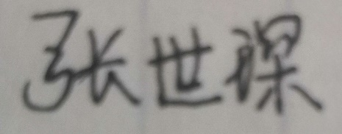

[503120700@qq.com](mailto:503120700@qq.com)